When you call for an ambulance, you expect one to come quickly, indeed the target time is 8 minutes in serious situations, but in some parts of Warrington, when the traffic is bad it could take a lot longer than this. In a medical emergency, there are lots of conditions where every minute help is delayed can decrease your chance of survival by 10-20%. In England around 25,000 people a year die who could have been saved, because the ‘chain of survival’ hasn’t started quickly enough.
Locals in Lymm have taken action to improve this. Working with the Parish Council, Lymm Round Table is running an essential first aid course – Heartstart – every month. The course teaches how to identify a crisis, how to get help and most importantly, how to keep a casualty alive. The course also teaches how to use the community defibrillators – there are now 16 in the Lymm alone, so with one for every 390 residents, Lymm is probably one of the best equipped villages in the country. The defibrillators are situated around the village in in locations like shops, schools, pubs and community centres. In Heatley Mere you’ll find the local one in the Co-Op.
Heartstart Co-Ordinator Graham Gowland said ‘This project is a fantastic example of the Big Society really working – funding from the parish council and charity fundraising, combined with local people working to make Lymm a safer place, while working with the NHS to co-ordinate our efforts – I’m really proud to live in Lymm!’
You can join the project by coming on the next course – held on the first Thursday of every month. To book a place Call/Text 07960 625236, email heartstart@lymmroundtable.co.uk of find them on Facebook - ‘Heartstart Lymm’.
Course Trainer Matt Stephenson commented ‘I’m really pleased to have moved to a village where so many people want to get involved, and Heartstart Lymm recently winning a Gold ‘Cardiac Smart’ award is just the icing on the cake.’ Matt is also setting up a Community First Responder Scheme in the village to further speed response times to 999 calls. Anyone interested in becoming a First Responder can email heartstart@lymmroundtable.co.uk for more information.
Simple steps really do save lives.
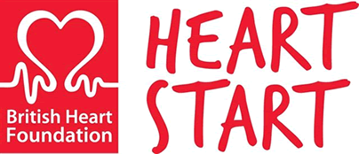

Chain Of Survival:
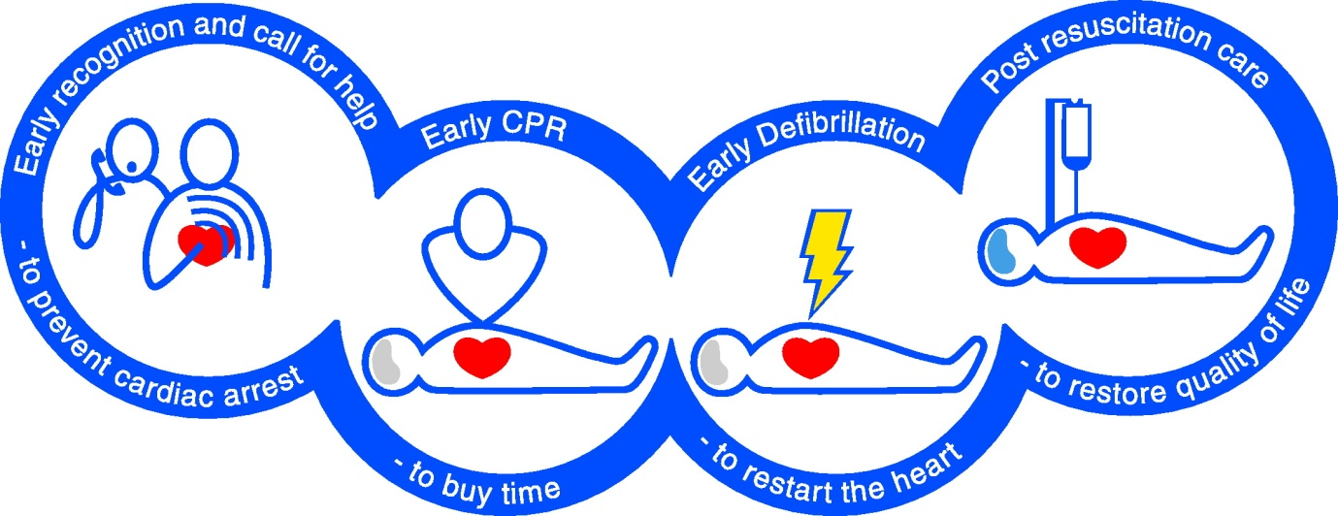

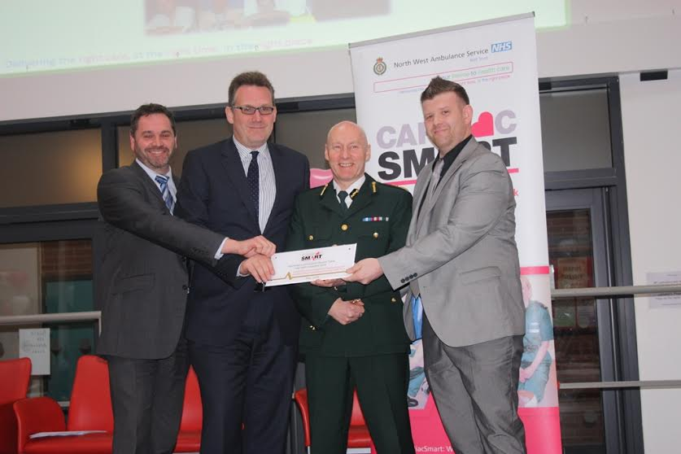
Heartstart Lymm/Lymm Round Table being presented with a Gold Cardiac Smart Award.
L-R Jon Beesley, Graham Gowland, Bob Williams CEO NWAS, Matt Stephenson

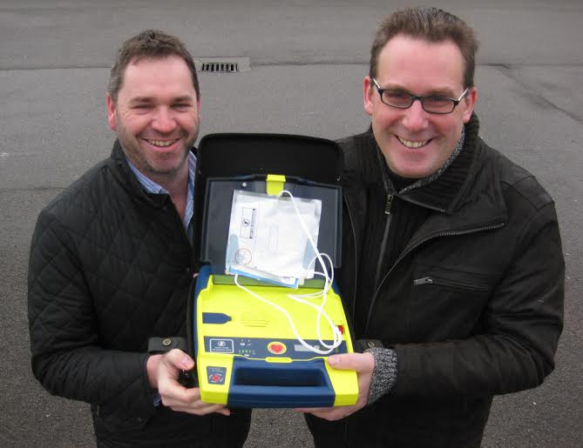
L-R Jon Beesley, Graham Gowland (Heartstart Lymm Trainers)

